GIT Remoting

SECTION-1 (Pushing assignments to remote repository)

39. Create a github account if you do not have already.

40. Login on into github account.

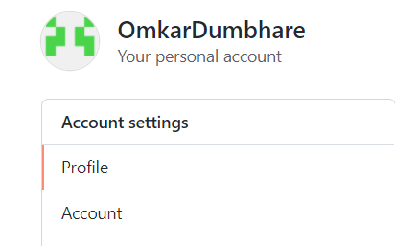

41. Create new public repository ‘freshersbatch-oct16’.

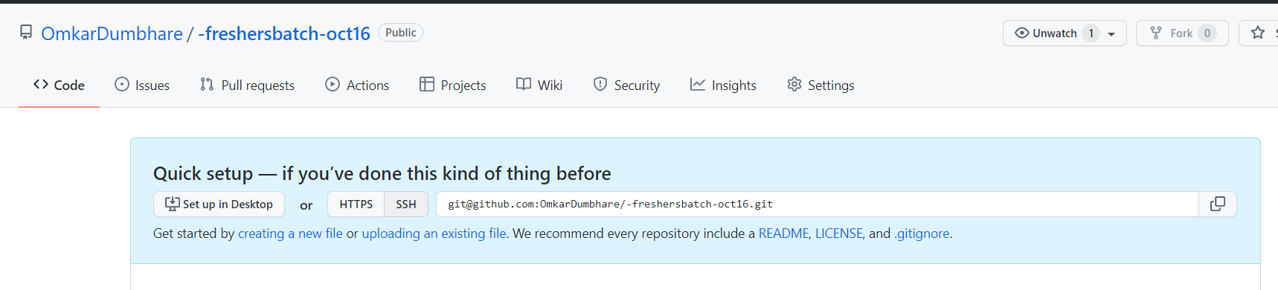

42. Commit & push any sample file to this repository under ‘Assignments’ directory

